ST10053504

MUHAMMAD

ASMAL

WEDE5020-POE-PART 1

Table of content

1. Website choice
2. Website assets
3. Website pages and content
4. References

Website choice

**Hunger relief worldwide**

**Description/About Us:**

The Hunger Relief Foundation is a nonprofit charitable organisation helping to plant more fresh water wells and pumps throughout the world. We also aim to Serve Humanity and provide clean and healthy water to all of mankind with the help of GOD. To provide food hampers to people in poverty stricken areas and to people during times of natural disasters.

**Purpose of the Hunger Relief Foundation:**

Assistance is provided unconditionally; assisting the needy, irrespective of human or animal, race, religion, colour, class, political affiliation or geographic location.

Since the inception, the organisation has been responsible for the delivery of life-saving goods and on-the-ground support for innumerable people, collectively valued at some R4.5 billion, in more than many countries across the globe, mainly South Africa.

Hunger Relief Foundation restores the hope and dignity of the most vulnerable in their time of need, rebuilding prosperous communities and empowering leaders of tomorrow.

**Services:**

* **Hunger Alleviation**

Backing the global fight against hunger, our aim is to contribute tellingly in the quest to save the lives of the starving and malnourished – human or animal.

From serving a warm plate of food to a starving child, to providing vital help to areas suffering with drought, and from distributing vital supplies to families living in war zones to feeding people displaced by natural disasters, we work tirelessly to ensure those in need are freed from hunger.

McCormick (2022: 24-25) highlights that apart from such short-term assistance, we continuously search for and deliver effective solutions, designed to give effect to long-term change, developing and implementing small-scale self-help agricultural projects within needy communities, empowering them to improve food security levels.

* **Water Provision**

We are all dependent on water for life… it’s the very necessary foundation for our growth and development. However, it is a scarce and dwindling resource in many areas of the world, and especially South and sub-Saharan Africa. A need exists to ensure people become increasingly responsible about saving and utilising water efficiently (Babich 2018: 27).

When disaster strikes, water takes on even greater importance, leading to our organisation having played a necessarily active role in assisting communities. From drilling boreholes and installing rainwater harvesting operations, to establishing purification systems and distributing bottled water, we have the flexibility to rapidly adapt to a community’s requirements, delivering water provision solutions which most appropriately ensure the sustainability of life (Al-imdaad-2002]

**Contact Information**

[HungerReliefFoundation@gmail.com](mailto:HungerReliefFoundation@gmail.com)

+27732100198

1 Link Road, Dawncliff, Westville,3629

Varsity College Entrance

Website Assets



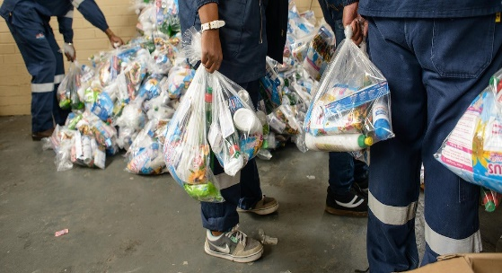





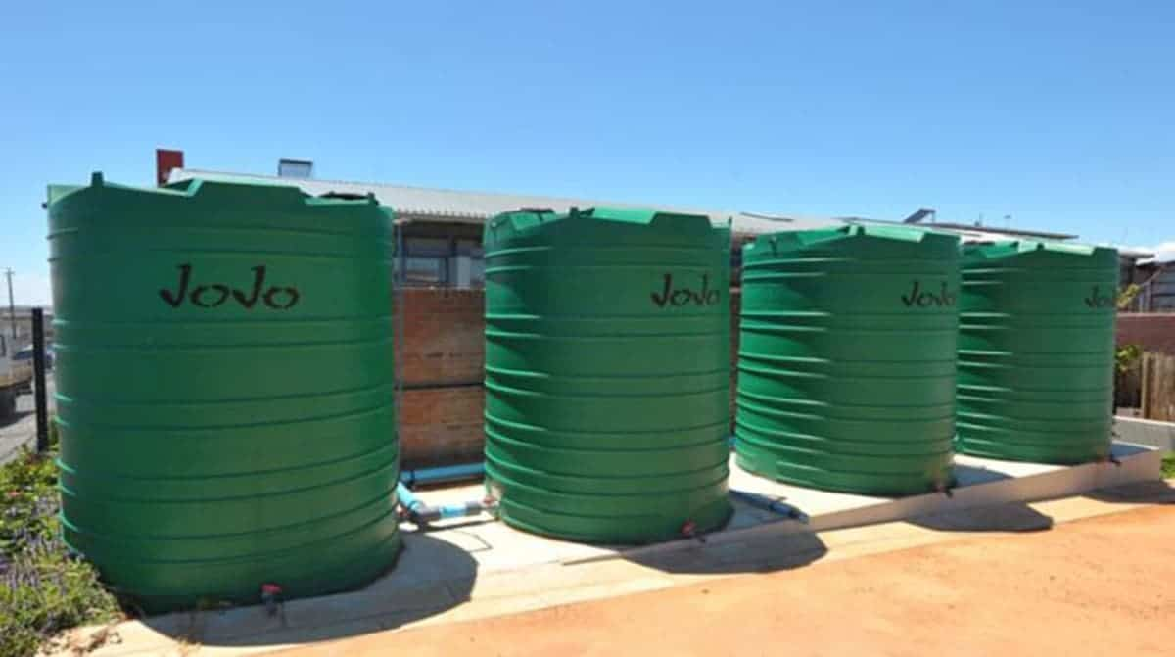



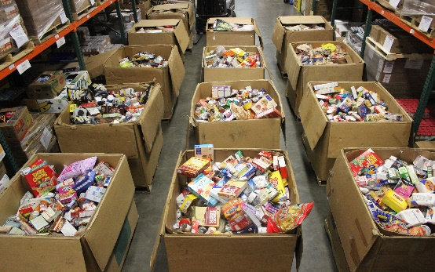

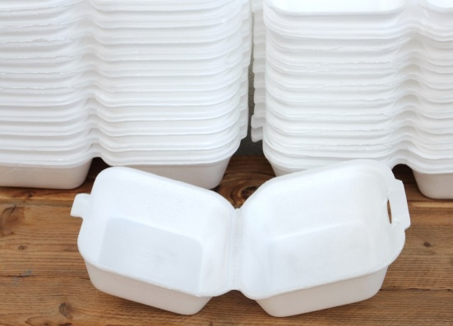

Website Pages and content

1. Homepage
2. Logo
3. Links to other pages
4. Picture
5. Explanation of my NPO with statistics
6. Copyright/Email/Year
7. About us
8. History
9. About us
10. Copyright/Email/Year
11. Contact us
12. Contact details
13. Map location
14. Copyright/Email/Year
15. News
16. Twitter link
17. Copyright/Email/Year
18. Products and Services
19. Services
20. List bar
21. Images
22. Copyright/Email/Year

Part 2

Improvements to part 1 on website

Changes in sizes of images on home page.

Improvements to part 2 in process document

No improvements needed to be made

Part 3

Improvements to part 2 in website

Mobile responsiveness was added to all the pages.

Minor changes in CSS like colours and backgrounds.

A new Twitter page was added to the news page

A map was added on the contact page.

Improvements to part 2 in process document

Improvements to part 1 was added in the process document.

Functionality

On the News page, I implemented a form of java script.

If you Click the box that says “click me for a donation”, the wording under it changes from “donate by just the press of a button” to “Congratulations!!! You have just donated R2.

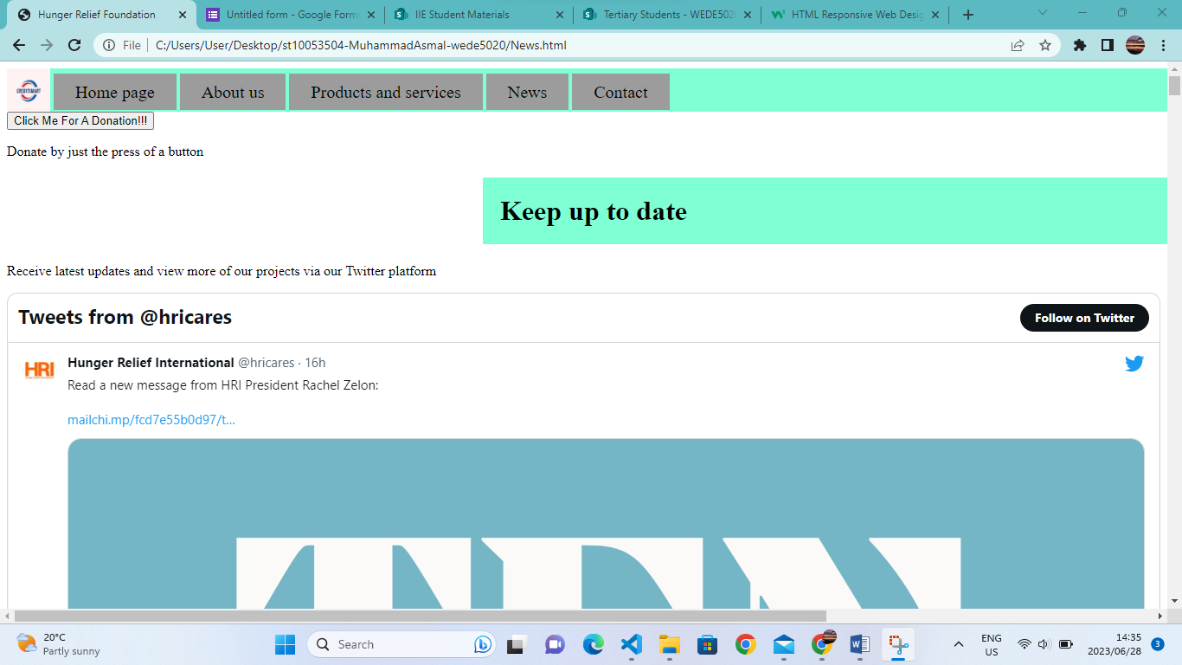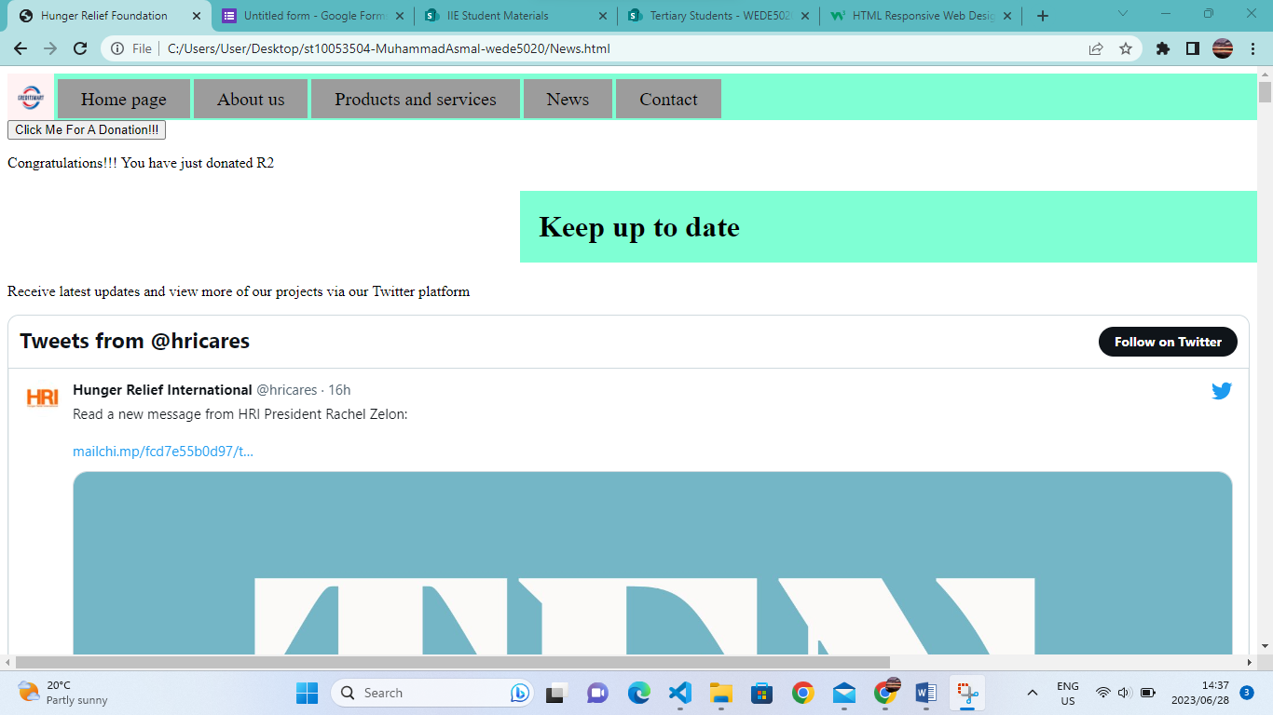

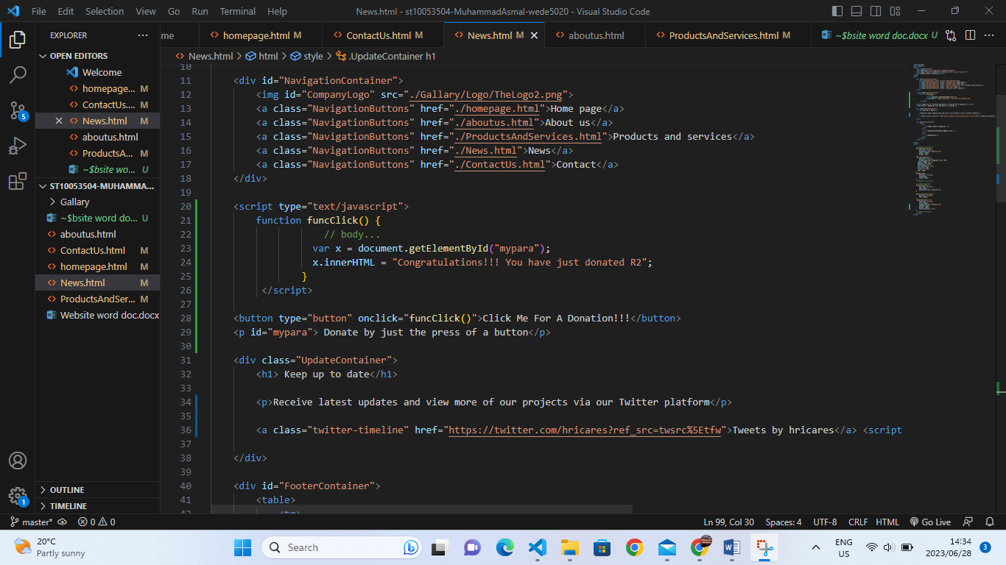

SEO

Some of the images are optimized with alt tags.

Content is not duplicated.

Not too long permalink.

The website has effective titles.

Used correct header tags throughout the website.

There are internal links.